**2018**

**Canada Vigilance Shiny App**

***An interactive visualization mechanism developed on Canada Vigilance Database***

USER MANUAL

**Developed By: Data Sciences Unit/ BI/ RMOD/ Health Canada**

**Developed for: MHPD/ Health Canada**

**Health Canada/ Santé Canada**



Table of Contents

1.0 Disclaimer 4

2.0 Information about Canada Vigilance Program 5

2.1 General Information 5

2.2 Canada Vigilance Adverse Reaction Documents 5

3.0 Definitions 6

3.1 Active Ingredient 6

3.2 Adverse Reaction (AR) 6

3.3 Adverse Reaction Report (AER) Number 6

3.4 Age 6

3.5 Age Group 6

3.6 Brand Name 7

3.7 Indication 7

3.8 Initial Received Date 7

3.9 Latest Received Date 7

3.10 Reaction Duration 7

3.11 Reason for Seriousness 7

3.12 Report Outcome 7

3.13 Reporter Type 8

3.14 Route of Administration 8

3.15 Serious Report 8

3.16 Source of Report 8

4.0 About CV Shiny App 9

4.1 About 9

4.2 CV Shiny App – Tool & Software 9

4.3 Browser Requirements 9

4.4 Logging On 10

5.0 Canada Vigilance Adverse Reaction Online Database 10

6.0 CV Shiny Data 11

6.1 Data Dependency 11

6.2 Data Flow 11

6.2 Data Updates 12

6.3 CV Shiny Data Tables 12

6.4 Understanding Data Elements 13

6.5 Database Specifications 14

6.6 Data Preparation 14

7.0 CV Shiny Interface 15

7.1 Bar Graph 16

7.1.1 How to Interpret the Bar graph? 16

7.1.2 Different views of the Bar Graph 17

7.1.2.1 Grouped Vs Stacked 17

7.1.2.2 Filtering based on Outcome: Death, Serious and Non-Serious 18

7.2 System Menu: The Side Panel 19

7.3 Search Tool Features 20

7.3.1 Brand Name Search 21

7.3.2 Seriousness Search 22

7.3.3 Age Range Selection 22

7.3.4 Gender Selection 22

7.3.5 Adverse Event Selection (PT term) 23

7.3.6 System Organ Class (SOC) search 23

7.3.7 Date Range Selection 24

7.3.8 Hit Search Button 26

7.3.9 No Results 26

7.4 Result Tabs and Dashboards 27

7.4.1 Reports Tab 27

Reporter Type 28

Seriousness 29

Reason(s) for Seriousness 30

7.4.2 Patients Tab 31

Gender 32

Age Groups 33

Age Histogram 34

7.4.3 Drugs Tab 36

Most Frequently Reported (Suspect and Concomitant) Drugs (Brand Name) 37

Most Frequently Reported Suspect Drugs (Brand Name) 38

Most Frequently Reported Concomitant Drugs (Brand Name) 39

Reports per Indication (all reported drugs) 40

Number of Drugs per Report 41

7.4.4 Reactions Tab 42

Most Frequent Adverse Events (Preferred Terms) 43

Most Frequent Adverse Events (High-Level Terms) 44

Report Outcome 45

7.4.5 About Tab 46

8.0 Data Download 47

8.1 Download Type 47

8.2 Select Columns 48

8.3 Download search criteria 49

8.4 Download 50

Changing the file format to Excel 50

9.0 Development Team 52

# 1.0 Disclaimer

This is a beta product. DO NOT use as sole evidence to support regulatory decisions or making decisions regarding medical care. Always consult a Health Care Professional about the risks and benefits related to the use of Health Products.

Before using this app, please read over the Canada vigilance adverse reaction Caveat, Privacy Statement and Interpretation of data document which is available at Canada.ca website [link](https://www.canada.ca/en/health-canada/services/drugs-health-products/medeffect-canada/adverse-reaction-database/medeffect-canada-caveat-privacy-statement-interpretation-data-extract-vigilance-adverse-reaction-online-database.html).

# 2.0 Information about Canada Vigilance Program

## 2.1 General Information

The Canada Vigilance Program is Health Canada's post-market surveillance program that collects and assesses reports of suspected adverse reactions to health products marketed in Canada. Post-market surveillance enables Health Canada to monitor the safety profile of health products once they are marketed to ensure that the benefits of the products continue to outweigh the risks.

The Canada Vigilance Program has collected reports of suspected adverse reactions since 1965. Adverse reaction reports are submitted by health professionals and consumers on a voluntary basis either directly to Health Canada or via Market Authorization Holders. The following health products marketed in Canada are collected by the program: prescription and non-prescription medications; natural health products; biologics (includes biotechnology products, vaccines, fractionated blood products, human blood and blood components, as well as human cells, tissues and organs); radiopharmaceuticals; and disinfectants and sanitizers with disinfectant claims. The information collected by the program can be accessed through the Canada Vigilance Online Database.

The Canada Vigilance Program is supported by seven Canada Vigilance Regional Offices who provide a regional point-of-contact for health professionals and consumers. Reports are collected by the regional offices before being forwarded to the Canada Vigilance National Office for further analysis.

The Canada Vigilance Program provides a variety of tools for health professionals and consumers to report suspected adverse reactions. Reporting is simple and can be done online, by phone or by submitting the Side Effect Reporting Form by fax or mail.

* [Health Canada](https://www.canada.ca/en/health-canada/services/drugs-health-products/medeffect-canada/canada-vigilance-program.html)

## 2.2 Canada Vigilance Adverse Reaction Documents

Click the link below to access:

[Caveat, Privacy Statement and Interpretation of Data Document](https://www.canada.ca/en/health-canada/services/drugs-health-products/medeffect-canada/adverse-reaction-database/medeffect-canada-caveat-privacy-statement-interpretation-data-extract-vigilance-adverse-reaction-online-database.html)

# 3.0 Definitions

Most of the definitions provided below are taken from Health Canada website. If you cannot find a definition that you are looking for, please try searching on the [Health Canada’s Website](http://www.hc-sc.gc.ca/dhp-mps/medeff/databasdon/glossary_definition-eng.php).

#### 3.1 Active Ingredient

An active ingredient is any component that has medicinal properties, and supplies pharmacological activity or other direct effect in the diagnosis, cure, mitigation, treatment or prevention of disease, or to affect the structure or any function of the body of man or other animals. The name and strength of each active ingredient contained in a health product is indicated on its packaging or label. Health products can contain multiple active ingredients. The same active ingredient(s) may be marketed under different brand names.

#### 3.2 Adverse Reaction (AR)

Adverse reactions are undesirable effects to health products. Health products include drugs, medical devices and natural health products. Drugs include both prescription and non-prescription pharmaceuticals; biologically-derived products such as vaccines, serums, and blood derived products; cells, tissues and organs; disinfectants; and radiopharmaceuticals.

Reactions may occur under normal use conditions of the product. Reactions may be evident within minutes or years after exposure to the product and may range from minor reactions like a skin rash to serious and life-threatening events such as a heart attack or liver damage.

#### 3.3 Adverse Reaction Report (AER) Number

The adverse reaction report number is the identification number of the report assigned by Health Canada.

#### 3.4 Age

Age of the patient when the adverse effect occurred. Age specific searches may be completed by specifying an age or a range of ages from the pick list. Ages have been rounded up to the closest year for searching, but are displayed in the results as received. Where the age is unknown, the reporter has not specified the patient's age in the report, or the reporter is unaware of the age. To retrieve cases where the age of the patient is "Unknown", the "age to" criteria must be set to "ALL".

#### 3.5 Age Group

Age group of the patient when the adverse effect occurred. The age group values are as follows:

Adolescent: greater or equal to 13 and less than 18 years

Adult: greater or equal to 18 and up to 65 years, inclusively

Child: greater or equal to 1 and less than 13 years

Elderly: greater than 65

Infant: greater than 25 days and less than 1 year

Neonate: greater than zero and up to 25 days, inclusively

#### 3.6 Brand Name

The brand name is the name assigned by the manufacturer under which the product is sold or advertised. A health product's brand name is indicated on its packaging or label. Multiple brand names may exist for products containing the same active ingredient. The same active ingredient(s) may be marketed under different brand names.

#### 3.7 Indication

Indication refers to the particular condition for which a health product was taken.

#### 3.8 Initial Received Date

The date the first version (version 0) of the adverse reaction report was received by Health Canada's Marketed Health Products Directorate.

#### 3.9 Latest Received Date

The date that the last follow-up report was received by Health Canada's Marketed Health Products Directorate. Latest received date is the same date as initial received date if no follow-up reports has been received.

#### 3.10 Reaction Duration

The duration of time from start of the reaction to the end of reaction.

#### 3.11 Reason for Seriousness

The reason for seriousness is represented by one of the following:

* Congenital Anomaly
* Death
* Disability
* Hospitalization
* Life Threatening
* Other Medically Important Condition

#### 3.12 Report Outcome

The report outcome represents the outcome of the reported case as described by the reporter at the time of reporting and does not infer a causal relationship. The report outcome is not based on a scientific evaluation by Health Canada.

The report outcome can represent one of the following:

* Death - The drug may have contributed to the death.
* Not recovered/not resolved - The patient has not yet recovered.
* Recovered/resolved with Sequelae - The patient recovered, but with an after effect possibly due to disease, injury, treatment, or procedure.
* Recovering/resolving - The patient is continuing to recover.
* Unknown - The reporter of report did not know the outcome at the time the report was submitted.

#### 3.13 Reporter Type

Indicates who reported the adverse reaction and their relationship to the patient.

#### 3.14 Route of Administration

Indicates the part of the body on which, through which or into which the product is to be introduced. (e.g., oral, topical, intramuscular, rectal)

#### 3.15 Serious Report

Defined as yes or no. A serious report contains a serious adverse reaction, determined by the reporter of the report at the time of reporting.

Health Canada defines a serious adverse reaction as:

"A noxious and unintended response to a drug, which occurs at any dose and requires in-patient hospitalization or prolongation of existing hospitalization, causes congenital malformation, results in persistent or significant disability or incapacity, is life-threatening or results in death. Important medical events that may not be immediately life-threatening or result in death or hospitalization, but may jeopardize the patient or may require intervention to prevent one of the outcomes listed above, may also be considered serious."

#### 3.16 Source of Report

Indicates the location through which the reporter sent the report.

* Community - Report received from the community (e.g., pharmacy).
* Hospital - Report received directly from a hospital.
* MAH (Market Authorization Holder) - Report received from a MAH.
* Other - Reports received from other source.

# 4.0 About CV Shiny App

The Canada Vigilance application (CV Shiny App) developed by the Research Management and Operations Directorate (RMOD) within Health Canada, was created to allow users to access the reports in the Canada Vigilance Adverse Reaction Database through interactive dashboards. The CV App allows users to effortlessly analyze thousands of reports and view results of specified searches. The CV App uses search tools to filter the reports contained in the Canada Vigilance Adverse Reaction Database and displays graphs, charts, and tables based on the user’s search query. The adverse events are coded according to the Medical Dictionary for Regulatory Activities (MedDRA) version 20.1; while the drug names are coded according to those used in the Canada Vigilance Adverse Reaction Database. Quarterly data update is the responsibility of the Canada Vigilance program (MHPD) and the support and maintenance of the CV application is the responsibility of the Data Sciences unit (RMOD).

## 4.1 About

CV Shiny app has been developed by the Data Sciences Unit of RMOD at Health Canada as part of the Open Data Initiative. This is a prototype experiment that utilizes publically available data (Canada Vigilance Adverse Reaction Online Database) and provides visualizations in an interactive format. Health Canada collects and maintains a high volume of adverse event reports associated with different drugs and products. This app allows users to effortlessly interact with the reports database, conduct searches and view results in highly interactive dashboards. To support innovation, coordination and to support Canadians, this interface permits the users to export search results (with no limitation to the number of rows) in various file formats such as CSV and Excel for further exploration and experimentation.

## 4.2 CV Shiny App – Tool & Software

CV Shiny App has been developed using an open source integrated environment known as R Studio and programmed using R, a language which is popularly used for statistical analysis. R Studio is available in 2 editions: Desktop and Server. At RMOD, we use the server based edition of R studio, which means that the application can be accessed using a web browser and a URL. This app has utilized various packages from the R Studio library and the one that produces interactive dashboards and visualizations is the Shiny R package and that’s why we named the app CV Shiny.

## 4.3 Browser Requirements

The CV Shiny app works best with Google chrome, and you may experience losing some functionality if you are using Internet explorer because the app uses multiple java scripts which are currently not available in IE. Therefore recommended browser is Chrome. Also note that the app uses the same URL while switching between tabs and trying multiple searches, which means that any searches performed are not saved in the user’s browser history, nor can they be returned to by pressing back or forward button on the browser. The only way to return to a once completed search is to re-input the same search specifications used at the time.

## 4.4 Logging On

The CV App is a web based application that does not require any installation of software or an account registration/login, the CV shiny app can be accessed via the following URL or the CV Shiny app link which is available at the bottom of every page in this document.

<https://shiny.hres.ca/CVShiny/>

Please note that this app can only be accessed on computers connected to HC network. And please open it in Google chrome browser as the app contains multiple java scripts functionalities which cannot be accessed if using Internet Explorer.

# 5.0 Canada Vigilance Adverse Reaction Online Database

The Canada Vigilance Adverse Reaction Online Database contains information about suspected adverse reactions (also known as side effects) to health products.

Reports are submitted by: consumers and health professionals, who submit reports voluntarily manufacturers and distributors (also known as market authorization holders), who are required to submit reports according to the Food and Drugs Act.

Information concerning vaccines used for immunization has only been included in the database since January 1, 2011. Information concerning human blood and blood components has only been included in the database since September 1, 2015.

Indication data has recently been added to the data extract files and the Detailed Adverse Reaction Report. Indication refers to the particular condition for which a health product was taken. For example, diabetes is an indication for insulin. Health products are often authorized for use in treating more than one indication.

The database cannot be used on its own to evaluate a health product's safety profile. It does not provide conclusive information on the safety of health products, and is not a substitute for medical advice. Should you have an issue of medical concern, consult a qualified health professional.

This database currently includes data from 1965-01-01 to 2017-12-31.

* [Health Canada](http://www.hc-sc.gc.ca/dhp-mps/medeff/databasdon/index-eng.php)

[Canada Vigilance Online Database Search](http://www.hc-sc.gc.ca/dhp-mps/medeff/databasdon/conditions_search-recherche-eng.php) – Export limited to a maximum of 1000 rows.

# 6.0 CV Shiny Data

CV Shiny app utilizes the same Canada Vigilance Adverse Reaction online Database that is publically available. Data Sciences unit at RMOD has developed its own internal Postgres Database which is used to serve the application. The data from the CV online database is extracted, transformed and loaded into the Postgres database for consumption by the R applications. Some renaming of the fields (mainly adding a prefix ‘cv_’) has been done for better understanding by the developers otherwise the database is exactly the same what is publically available on the Health Canada website.

## 6.1 Data Dependency

CV shiny app data is provided by the Canada Vigilance Adverse Reaction Online Database. The recency of the data and the MedDRA version is therefore dependent on when the data source is updated, and is the responsibility of the Canada Vigilance Program. For more information, please refer to [Canada Vigilance adverse reaction online database](https://www.canada.ca/en/health-canada/services/drugs-health-products/medeffect-canada/adverse-reaction-database.html).

## 6.2 Data Flow

Canada Vigilance adverse reaction data is collected in the CVP online database. Adverse reaction reports are submitted by consumers of health products, health professionals, market authorization holders. This data is updated quarterly every year, and at every update, this data is extracted and loaded into an internal Postgres database (owned by RMOD) automatically using a code script. The CV shiny app is served by this Postgres database which is owned and maintained by data sciences unit at RMOD.

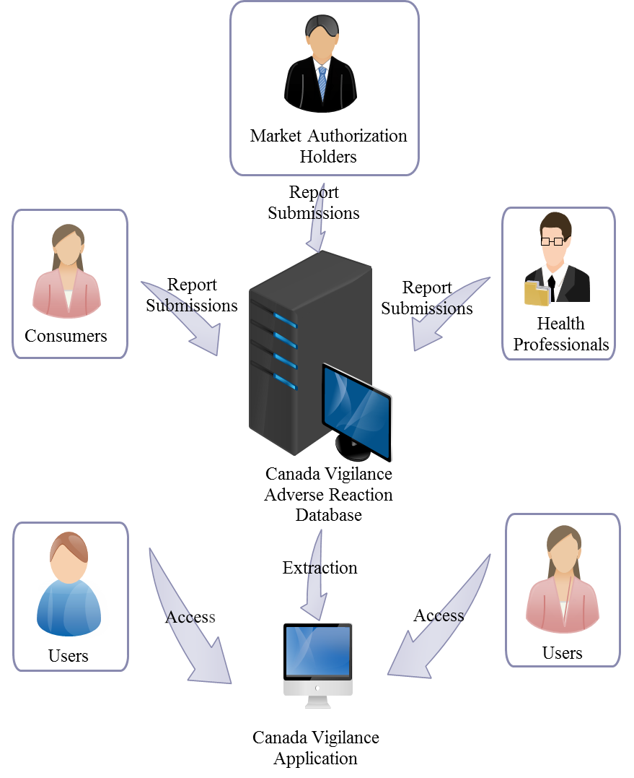

## 6.2 Data Updates

Data updates for CV Shiny app are dependent on the data updates of the Canada Vigilance online database which is updated quarterly (4 times per year). Every time the CV online database is updated, the internal Postgres database pulls the updates and uploads them into the database using a background script.

## 6.3 CV Shiny Data Tables

There are 11 tables in the Canada Vigilance Database; the CV Shiny app uses 6 tables and only few columns from those tables. Below is an Entity Relationship diagram of the data tables utilized by CV Shiny app.

Contains information about reports

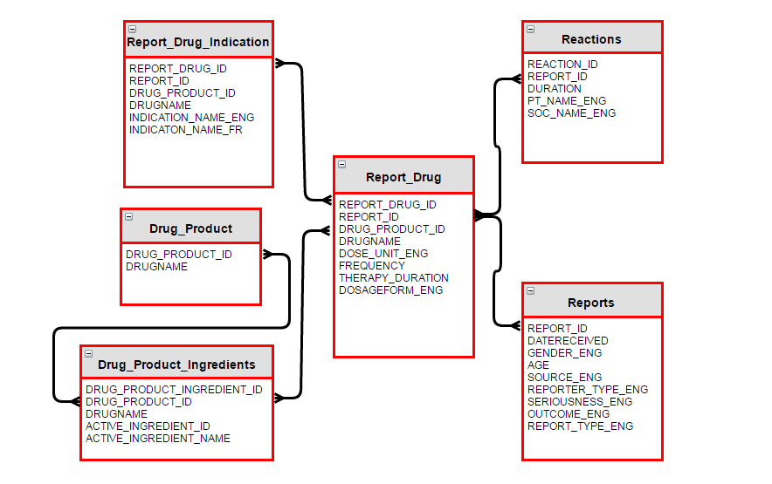

Contains information about indication

Contains information about drug brand name

Contains information about drug and active ingredients

Contains information about adverse reactions

Contains information about patient characteristics

Reports: reports Columns correspond to fields in report to canada vigilance. They contain information about patient characteristics. Joins Report_drug and Reactions by report_id.

Drug_product_ingredients: drug_product_ingredients Columns map between drug names, product ids, and active ingredients. Joins report_drug by drug_product_id.

Report_drug: report_drug Columns correspond to fields in report to Canada vigilance that record data about the specific therapy the patient was undergoing. Joins reactions and reports by report_id. Joins drug_product_ingredients by drug_product_id.

Reactions: reactions Columns are fields in Canada vigilance reports that detail the reaction had by the patient. Maps MedDRA terms to report_id. Joins meddra.version by pt_code. Joins reports by report_id.

Dynamically named table based on latest version in the history table of the date_refresh table. Version 20.1 will have a table name v_20_1. Columns contain MedDRA hierarchy, a controlled vocabulary of medical terms for regulatory purposes. Joins reactions by pt_code.

## 6.4 Understanding Data Elements

|  |  |
| --- | --- |
| Attribute Physical Name | Attribute Logical Name |
| REPORT_DRUG_ID | Report Drug Identifier |
| REPORT_ID | Adverse Reaction Report (AER) Number (6 digits) |
| DRUG_PRODUCT_ID | Drug Product Identifier |
| DRUGNAME | Brand Name |
| INDICATION_NAME_ENG | Indication - English |
| INDICATON_NAME_FR | Indication - French |
| DRUG_PRODUCT_INGREDIENT_ID | Drug Product - Active Ingredient Identifier |
| ACTIVE_INGREDIENT_ID | Active Ingredient Identifier |
| ACTIVE_INGREDIENT_NAME | Active Ingredient Name |
| DOSE_UNIT_ENG | Dose Unit - English |
| FREQUENCY | Frequency |
| THERAPY_DURATION | Therapy Duration |
| DOSAGEFORM_ENG | Dosage Form English |
| REACTION_ID | Reaction Identifier |
| DURATION | Reaction Duration |
| PT_NAME_ENG | Adverse Reaction Term - English |
| SOC_NAME_ENG | System Organ Class - English |
| DATERECEIVED | Latest Received Date |
| GENDER_ENG | Gender - English |
| AGE | Age |
| SOURCE_ENG | Report Source - English |
| REPORTER_TYPE_ENG | Reporter Type - English |
| SERIOUSNESS_ENG | Serious Adverse Reaction - English |
| OUTCOME_ENG | Report Outcome - English |
| REPORT_TYPE_ENG | Type of Report - English |

For detailed information on Data structure, Attributes logical names, attributes physical names and data types, please refer to Canada Vigilance Adverse Reaction Online Database - [Data Structure](https://www.canada.ca/en/health-canada/services/drugs-health-products/medeffect-canada/adverse-reaction-database/canada-vigilance-adverse-reaction-online-database-data-structures.html).

## 6.5 Database Specifications

This app is connected to a PostgreSQL database. A foreign data wrapper creates a live link from the Canada vigilance adverse reaction online oracle database to the PostgreSQL database as the remote schema. This schema is copied to the current schema. This copy prevents excess demand on the foreign server and allows for cleaning and versioning of the database.

## 6.6 Data Preparation

As previously mentioned that CV shiny app is served by CVP online database, therefore there are not many changes done to the data before using it to serve this app. Although every field used in this was indexed with simple B+ tree index, this has been done to enhance performance and to make sure the app retrieve results faster.

Other than indexing, the only major data preparation that has been done before feeding the data into the app is related to age column, this is to make sure that app allows the user to search based on a specific age range and whether or not to include age estimates and unknown ages. This is done as follows:

For reports where the age of the patient is estimated, but no explicit age_y is given, a new column age_y_clean was created. This column adds ages in years for estimates. For example: The age group for the reports are often left blank so they were generated from the age and age_unit_eng columns. For example: a value of 4 in age and 'decades' in age_unit_eng is given a value of 45. Note: we might get a better estimate by finding the distribution of ages between each range and proportionally designating such values. For the age group chart we need accurate groups that are often left blank. We created a column within the reports table called age_group_clean to calculate the age group from age_y.

Note: this does not use age_y_clean since unless estimates are proportionally allocated, we encounter problems on borders of age groups. A MedDRA schema that creates a table for every new MedDRA version was created. It provides the mapping between hlt_name, pt_code, and smq_name, required for the app.

# 7.0 CV Shiny Interface

CV Shiny app is hosted on the Health Canada internal server and can be accessed via following URL only on HC network computers and devices.

<https://shiny.hres.ca/CVShiny/>

On the landing page, you will see the following screen.

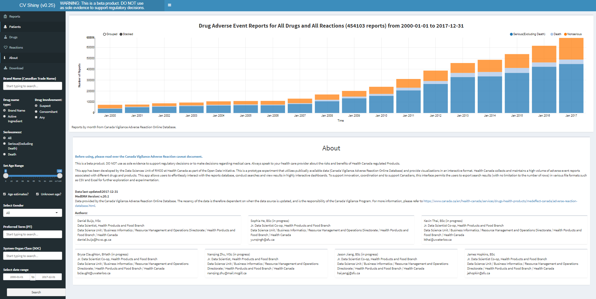

## 7.1 Bar Graph

The bar graph on the very top of landing page shows the number of reports on a particular date. The X – axis displays the time period and the Y-axis displays the number of reports. The X –axis is based on the date range selection and the Y – axis adjusts itself from zero to the maximum number of reports for a particular outcome of a drug and reaction search. By default it shows the number of reports for all drugs and all reactions from 200-01-01 to 2017-12-31 (or last data update date). The end date will change every time there is a new data update in ARIS database. If you are search start and end date is within a range of 23 months, the graph will display the reports per month. If you are searching for more than 23 months or multiple years, the graph will display the number of reports per year and by default it displays every year with a prefix ‘Jan’ before the year.

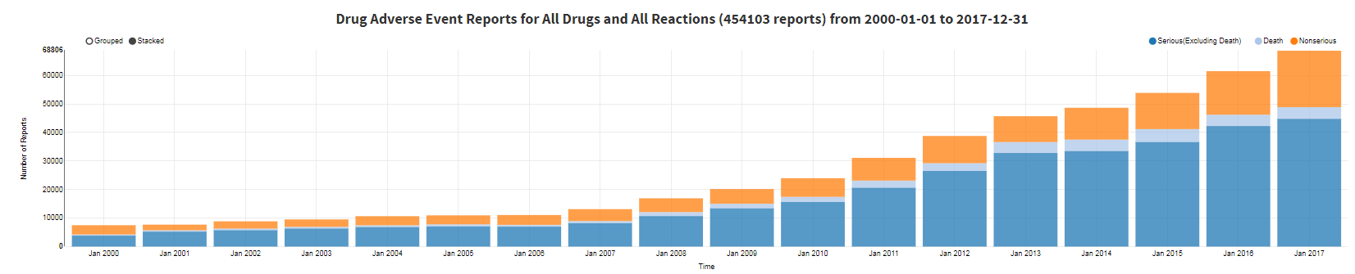

Reports per year

____________________________________________________________________________________

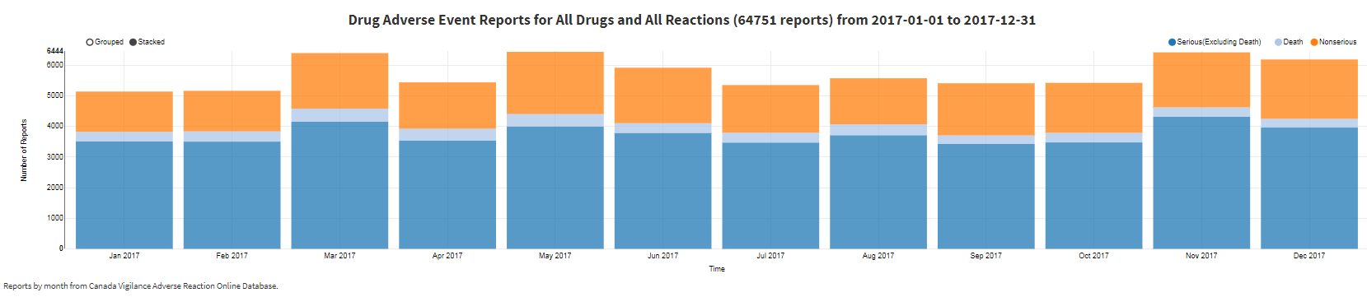

Reports per month

### 7.1.1 How to Interpret the Bar graph?

Your search criteria (Drug + Reaction), the total number of reports for your particular search, and the time period will be displayed on the top of the bar graph. To view the number of reports for a particular month or year (depending on your search), simply hover over that time period and you can see the number of reports broken down into: Serious (Excluding Death), Death and Non- serious.

### 7.1.2 Different views of the Bar Graph

#### 7.1.2.1 Grouped Vs Stacked

The Bar graph has 2 flavors; you can view it as stacked or as grouped. You can make this selection from the top left of the bar graph, simply by click and select feature. See images below:





Stacked View

_____________________________________________________________________________________



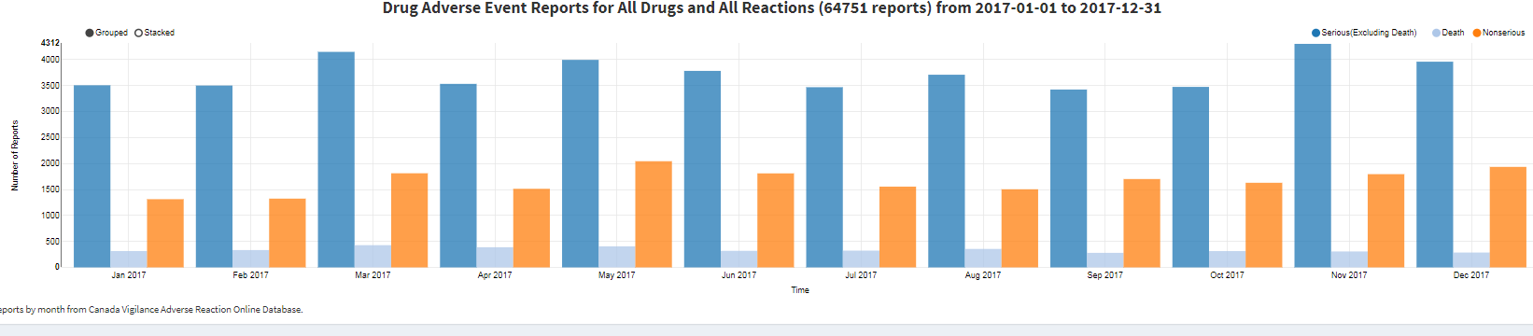

Grouped View

#### 7.1.2.2 Filtering based on Outcome: Death, Serious and Non-Serious

By default, the bar graph display reports including Serious (Excluding Death), Death and Non- serious outcome based on your search criteria. If you like to view the reports for just one type of outcome or for any two types of outcome, simply deselect the outcome or outcomes that you don’t want to include in your results. The de-selection panel is on the top right of the bar graph.



For example: The below bar graph displays the reports which include only the Serious (Excluding Deaths) reports. This is done by deselecting the Death and Non-serious reports by clicking the radio buttons on the deselecting panel.

Death and Non-serious deselected



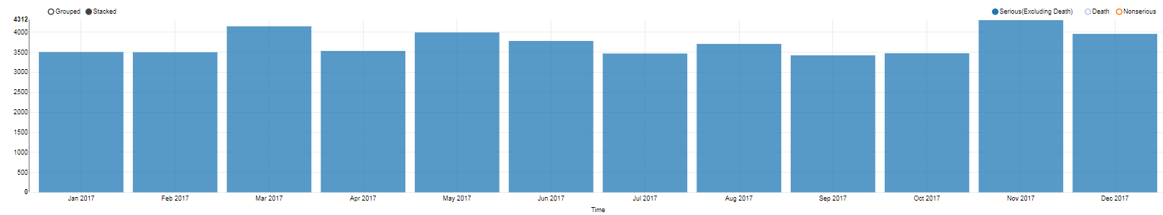

To view the number of reports for a particular month or year, simply hover over the bar for that month or year.

## 7.2 System Menu: The Side Panel

By default, the landing page displays the About Tab containing information about the application such as Disclaimer, Caveat document, Data last updated date, MedDRA version and the Authors of the application. Below is a snapshot of the side panel with a brief description of each field/ tab.

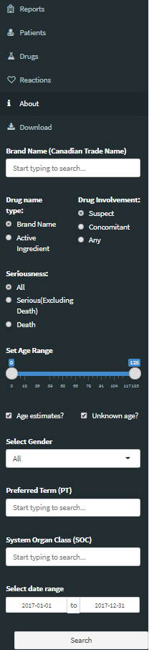

Different View Tabs displaying different dashboards based on selection of Brand Name/ AI, Adverse Event Term/ SOC and Date Range. If nothing is selected, dashboards will display the results for all drugs, all reactions from 2000-01-01 to 2017-12-31.

Search filters including brand name, drug involvement, seriousness, age range, gender, PT term, SOC and date range.

## 7.3 Search Tool Features

There are multiple search filters avialable in this application, and based on your search your results will be filtered. You can always see the overview of your search crietria on top of the bar graph. Below is a snapshot of the search panel followed by an expalnation of each filter and how to use that filter. Once you have input your search criteria, hit the Search button at the very bottom of this panel to calculate the results output of your search.

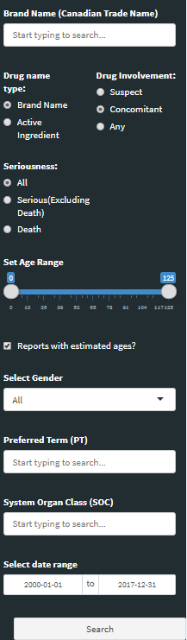

### 7.3.1 Brand Name Search

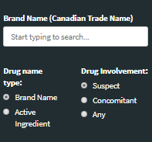 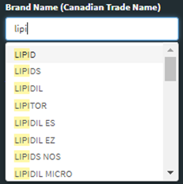 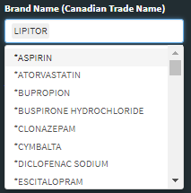

Within the Brand name search filter you have multiple options.

By default, the system will search for brand name, but you can search for a drug by Brand name or by Active ingredient, simply click and select the radio button next to your preference under ‘Drug Name Type’ before searching for a particular drug. Once you selected the drug name type, select the drug involvement.

Additionally by default, the app filters the results for ‘Suspect’ drug involvement but you can choose between Suspect, Concomitant and Any by clicking and selecting the radio button next to your preference below ‘Drug Involvement’ before searching for a paticular drug.

Once the Drug Name type and Drug Involvement have been selected, you can search for the drug by simply tying the drug name in the field provided. This search box is a Type and Select feature, which means when you start typing a drug name, the app will filter the results and display only the related drugs and from there you can select the drug that you want to include in your search results. This feature has an added advantage of multiple drugs selection. Once you have selected a drug, you can add multiple drugs to it, simply by following the same type and search criteria. See an example below:

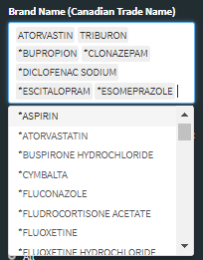

Multiple drugs selection

### 7.3.2 Seriousness Search

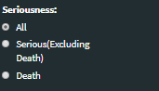

Seriuosness search functionailty is right below the Drug name search functionailty. You can filter your results based on the outcome of an Adverse event. By default the app searches for All types of outcomes but you can also filter your results down to just Death or Serious (Excluding Death) outcomes, simply by clicking the radio buton next to your preference.

### 7.3.3 Age Range Selection

Age range 27 to 84 selected

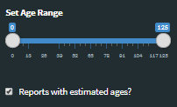 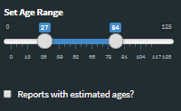

Reports with age estimates Unchecked

The default age range selction is from zero to 125 years. You can simply select a different age range by moving the age range slider (see images above). In addition to age range selection, the app also features the selection of Age estimates(age estimated in deacdes) and unknown ages (age not provided). You can simply check or uncheck this selection. By default the app search includes all age estimates and unknown ages. To exclude age estimates and unknown ages from your search results, simply uncheck the ‘Reports with estimated ages’ check box below the age range slider.

### 7.3.4 Gender Selection

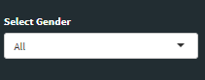 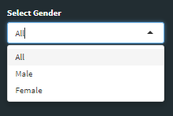

Gender selection is just below the Age range slider. By default it is set to All gender which includes Male, female, not specified and unknown. To search for a specific gender, simply click the drop down arrow and make your selection. Please note the selection feature only lets you select among Male, Female or All. Where the gender is Not specified, the reporter did not specify the gender of the patient and where the gender is unknown, the reporter is unaware of the gender.

### 7.3.5 Adverse Event Selection (PT term)

 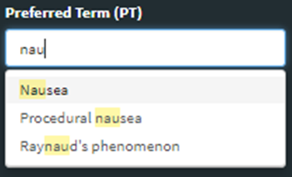 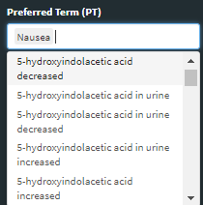

Preferred term search box is right below the gender selection box. It is a Type and select feature and similar to brand name search you can do multiple adverse terms selection. To make a search, simply start typing the PT term and the matched terms will start to appear in the box, and once you see your required PT term, simply clcik on it and it will be selected. If you want to add more terms, repeat the above step and it will select additional terms.

### 7.3.6 System Organ Class (SOC) search

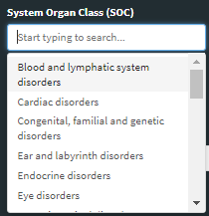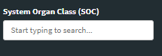 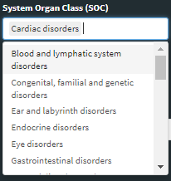

If you would like to search by SOC, there is a SOC search box available right below the PT term search box and above the date range selection. Similar to PT term selection, you can start typing the SOC term and once it appears in the box, simply click and it will be selected. You can select multiple SOC terms just like PT terms and brand names search.

### 7.3.7 Date Range Selection

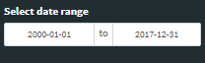

The date range selection feature is at the very end of the search panel. By default, the app is set to search data from 2000-01-01 to the most reecent release date. But, it allows you to search data between any two dates ranging from 1965-01-01 to most recent release date. To change the start or end date of your search, simply click on that date range box and the following box will appear.

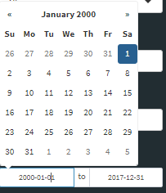

Now click on the Month Year on the top of this box and the following box will appear.

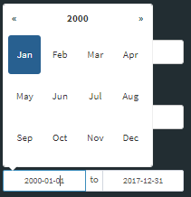

Now click on the Year on the top and the following box will appear.

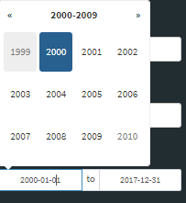

Now to change the year, simply click the << OR >> arrows next to year range to view different years. Once you see the year that you want to include in your search, click on that year and it will then ask you to select month, and then date. Follow the same procedure to set an end date for your search.

Example set start date to 1999-02-19

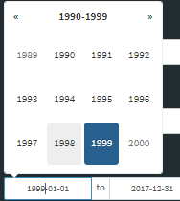 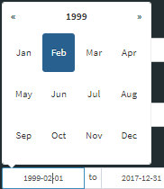 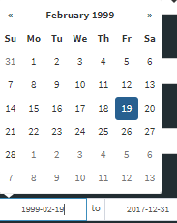

You can also change the dates by selecting the column of start or end date and typing in the new date in the format YYYY-MM-DD. See snapshot below.



Note that date selection feature only lets you select a date between 1965-01-01 to most recent release date.

### 7.3.8 Hit Search Button

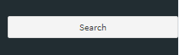

Once you have fill in your search criteria, Hit the <Search> button to view results.

Upon clicking the search button, the app will calculate the results and display the calculation in progress icon as shown below.

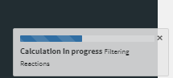

### 7.3.9 No Results

If your serach query does not have any matching results, the app will display a ‘No results found’ message as shown below. This is because your search criteria has no related data. Please modify your search. To go back to the app, simply click on the Dismiss button that appears on this messsage.

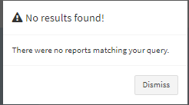

## 7.4 Result Tabs and Dashboards

On the left side panel, on top of search panel, you will find the following tabs (screenshot below). By default the dashboards presented in these tabs will display the results for All Drugs and All reactions. Once you have entered your search criteria and clicked on the search button, after that you can view these tabs to display dashboards based on your search query. Every dashboard has the big bar graph on the top followed by various other dashboards relevant to that particular tab. All tabs have dashboards with a tool tip feature like  ; hovering over this icon will provide you with an explanation of the information presented in that dashboard.

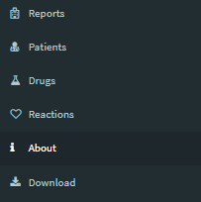 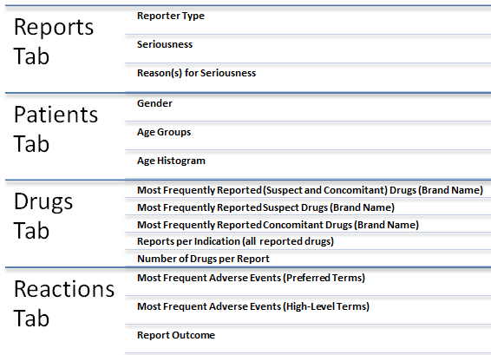

### 7.4.1 Reports Tab



This is the very first tab on the very top of the left side panel. Reports tab contains 3 dashboards: Reporter Type, Seriousness, and Reason(s) for Seriousness. Below are the visualizations of these three dashboards with default selection of All drugs and All reactions from 2000-01-01 to 2017-12-31.

#### Reporter Type

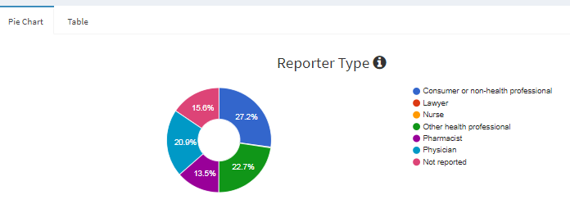

Tool Tip

This pie chart dashboard displays the qualification of the reporters who have filled the reports. It indicates who reported the adverse reaction and their relationship to the patient. Please note that slices may not be visible if they are too small. The columns are categorised as Consumers or Non health professionals, Lawyers, Nurse, other Health Professional, Pharmacists, and Physician and Not reported. The Not reported column refers to those who do not fall under any of the other qualifications. This dashboard displays the results in percentage but, if you hover over the dashboard (hover over every slice) you can see the actual number of reports for each qualification. You can also view the total number of reports (n) in a tabular format by simply clicking on the ‘Table’ tab next to the ‘Pie chart’ tab. See snapshot below.

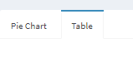 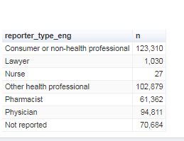

#### Seriousness

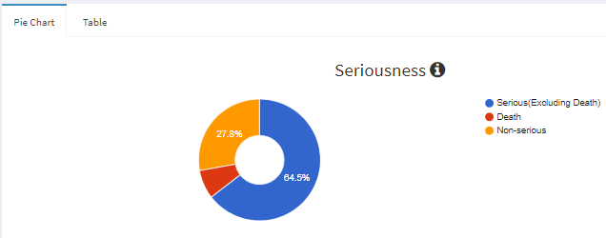

Tool Tip

The Seriousness dashboard displays the percentage of reports being marked as Serious (Excluding Death), Death and Non-serious. A serious (excluding death) report contains a serious adverse reaction but the outcome was not death as determined by the reporter of the report at the time of reporting. A Death report contains a serious adverse reaction in which the outcome was death as determined by the reporter of the report at the time of reporting. And a Non-serious report contains a non-serious adverse reaction outcome as determined by the reporter of the report at the time of reporting. Please note that slices may not be visible if they are too small. This dashboard displays the results in percentage but, if you hover over the dashboard (hover over every slice) you can see the actual number of reports for each qualification. You can also view the total number of reports (n) in a tabular format by simply clicking on the ‘Table’ tab next to the ‘Pie chart’ tab. See snapshot below.

 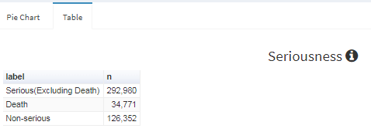

#### Reason(s) for Seriousness

Tool Tip

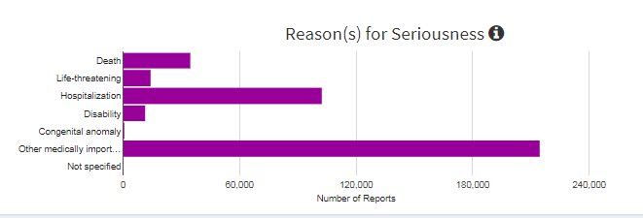

Reason(s) for Seriousness: The serious condition which the adverse event resulted in. This dashboard displays the total number of serious reports (including deaths) for a given selection. On the bar chart, it displays the qualifications for reasons of seriousness on the X-axis and the corresponding number of reports for those particular reasons on the y-axis. The qualifications for the reason of a serious report displayed in this bar chart are: Death, Life-threatening, Hospitalization, Disability, Congenital anomaly, other medically important condition and not specified. Not specified serious reports are those where the reporter has determined the outcome of adverse reaction to be serious without mentioning the actual reason for seriousness. Note: The total may sum up to more than the total number of reports because reports can be marked as serious for multiple reasons.

This dashboard displays the results in bars with Y-axis displaying the number of reports, but, if you hover over the dashboard (hover over every bar) you can see the actual number of reports for each qualification.

### 7.4.2 Patients Tab

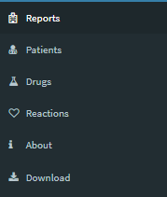

This the second tab from top in the left hand side panel. It contains dashboards specific to patients such as gender and age groups. Patients tab contains 3 dashboards: Gender, Age Group and Histogram of Patient Ages. Below are the visualizations of the three dashboards with default selection of All drugs and All reactions from 2000-01-01 to 2017-12-31.

#### Gender

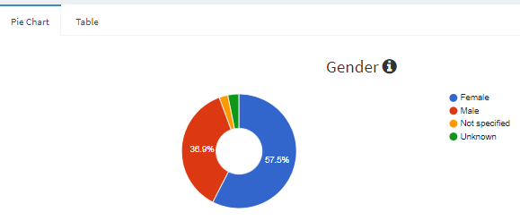

Tool Tip

This dashboard is a Pie chart and has qualifications of Male, Female, Not specified and Unknown. For a given selection of drug, reaction and the date range, this dashboard provides a visualization of the total number of male and female patients. In addition to Male and female, there is an Unknown and Not Specified label. Unknown includes all the reports in which the reporter explicitly marked Unknown and Not specified includes those reports in which the gender information is not provided. This dashboard is relatively very useful if you want to compare the effect of a particular drug and a reaction on males vs. females. This dashboard displays the results in percentage but, if you hover over the dashboard (hover over every slice) you can see the actual number of reports for each qualification. You can also view the total number of reports (nn) in a tabular format by simply clicking on the ‘Table’ tab next to the ‘Pie chart’ tab. See snapshot below.

 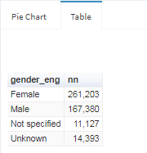

#### Age Groups

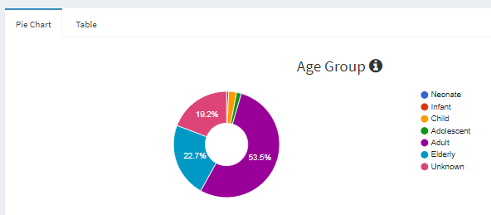

Tool Tip

This pie chart displays the number of reports as percentages for age group. Age groups labeled as Neonate, Infant, Child, Adolescent, Adult, Elderly and Unknown. Refer to definitions for the age breakdown of age groups or simply hover over the information icon next to Age group title to see the breakdown of ages for different age groups. Unknown is the age group that includes all reports for which no age information has been provided. This dashboard displays the results in percentage but, if you hover over the dashboard (hover over every slice) you can see the actual number of reports for each qualification. You can also view the total number of reports (n) in a tabular format by simply clicking on the ‘Table’ tab next to the ‘Pie chart’ tab. See snapshot below.

 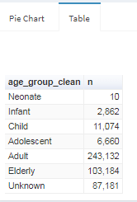

#### Age Histogram

Tool Tip

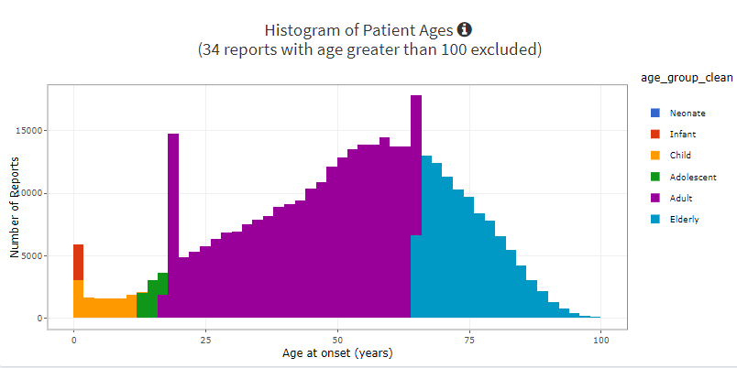

This dashboard displays the age group and associated number of reports for a particular selection of drug, adverse event term and date range. It displays the number of reports per age and is colour coded by age group. Please note that this dashboard excludes any report with age greater than 100. Please note that each bin groups 2 years and therefore you may find certain age group stacking over each other. Hover over the histogram to view the actual count of reports for particular section. You can also deselect a particular age group or groups by clicking on that age group in the legend section. For example, if you wish to deselect the adult age group from the above histogram, simply click on adult in the right hand side legend pane and you will all age groups except adults. See the following histogram snapshot.

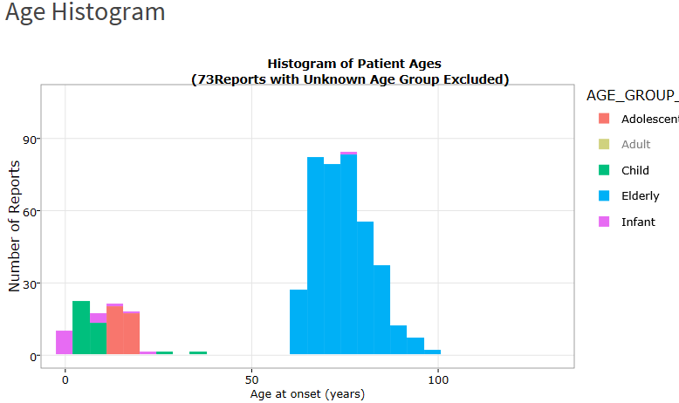

Additional to enlarge the histogram on a particular area, use the tool bar above the histogram. This tool bar is visible once you hover around the top of age histogram. This toolset has multiple features. See the features list below:



Below is the functionality of the tools available in this panel:

|  |  |
| --- | --- |
|  | Taking a snapshot of Plot and download it as a .png file. If unavailable in Internet Explorer, use Plotly Cloud. |
|  | Tool to Zoom into the plot. Click the icon and then click the area on the plot that you would like to Zoom into, to revert back, simply double – click the plot. |
|  | Pan Button, lets you scroll left, right, up and down on the plot. Click the button, a pan cursor will appear on the plot, then left click and move your pan button cursor on the plot. |
|  | Zoom In and Zoom Out Buttons |
|  | Auto scale button cover the full date range |
|  | Home button to reset the axes |
|  | By clicking this button, closet data will be shown on hover over the graph |
|  | This button is use to compare data on hover |
|  | Link to the Plotly site - used to create the plot |

### 7.4.3 Drugs Tab

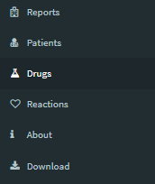

The Drugs tab is the third tab from the top on the side panel. The dashboards presented in this tab display graphs related to drug involvement – suspect or concomitant and number of drugs in a report. The default selection for all dashboards is All drugs and All reactions from 2000-01-01 to 2017-12-31. This tab contains five dashboards as follows:

#### Most Frequently Reported (Suspect and Concomitant) Drugs (Brand Name)

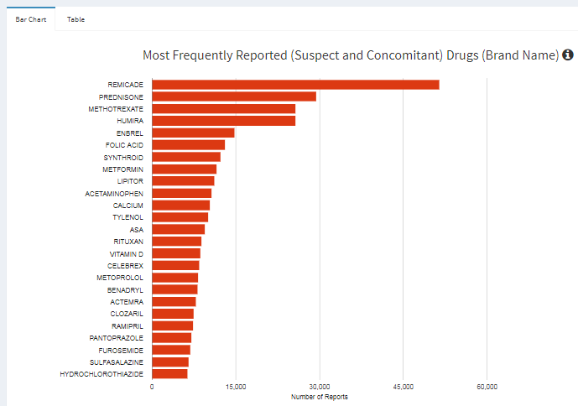

Tool Tip

This bar graph displays the most frequently reported drugs (Brand names only and not active ingredients) including both suspect and concomitant on the Y –axis and the number of reports on the X-axis. This plot includes all drugs in the matching reports. The search query filters unique reports, which may have one or more drugs associated with them. This dashboard displays the results in a bar graph that allows you to view the top 25 Drug involvement from most to least and, if you hover over the dashboard (hover over every bar) you can see the actual number of reports for each drug. You can also view the total number of reports (n) in a tabular format by simply clicking on the ‘Table’ tab next to the ‘Bar chart’ tab. See snapshot below.

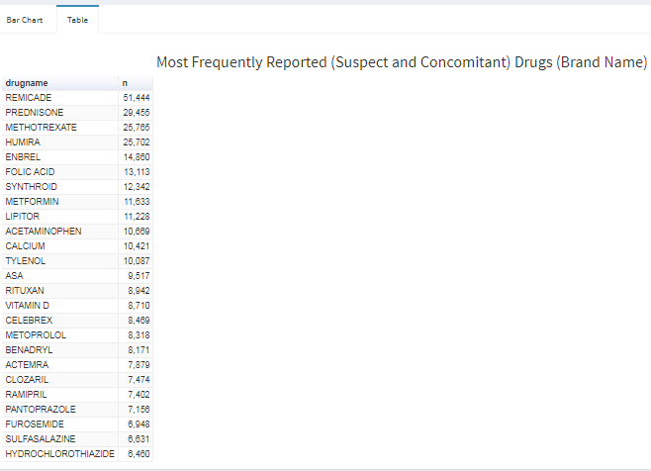

#### Most Frequently Reported Suspect Drugs (Brand Name)

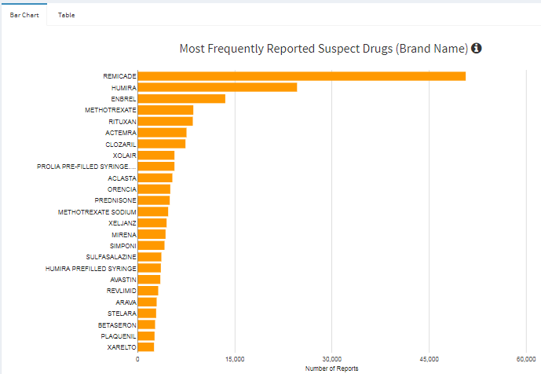

Tool Tip

This bar graph displays the most frequently reported suspect drugs (Brand names only and not active ingredients) including only suspect drugs on the Y –axis and the number of reports on the X-axis. This plot includes all drugs present in the matching reports. The search query filters unique reports, which may have one or more drugs associated with them. The reporter suspects that the health product caused the adverse reaction. This dashboard displays the results in a bar graph that allows you to view the top 25 Drug involvement as a suspect from most to least and, if you hover over the dashboard (hover over every bar) you can see the actual number of reports for each suspect drug. You can also view the total number of reports (n) in a tabular format by simply clicking on the ‘Table’ tab next to the ‘Bar chart’ tab. See snapshot below.

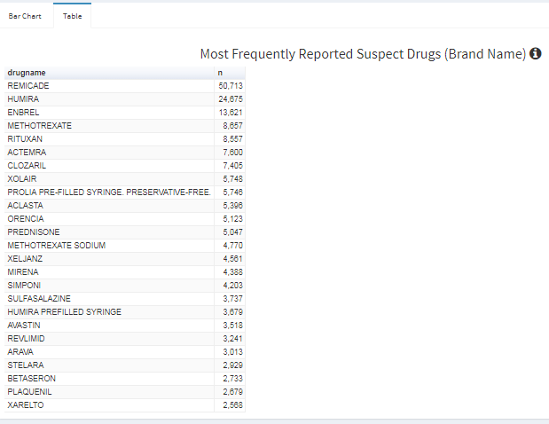

#### Most Frequently Reported Concomitant Drugs (Brand Name)

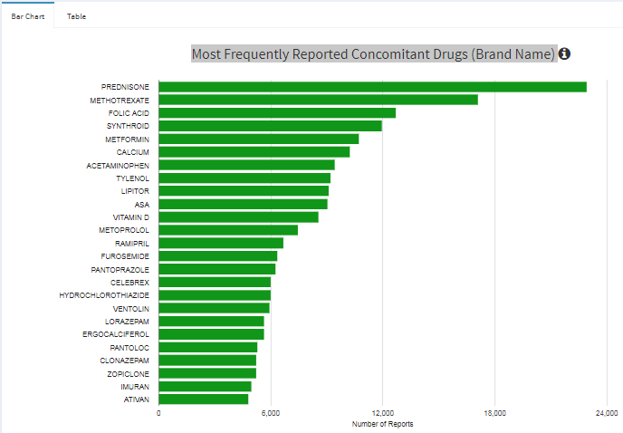

Tool Tip

This bar graph displays the most frequently reported concomitant drugs (Brand names only and not active ingredients) including only concomitant drugs on the Y –axis and the number of reports on the X-axis. This plot includes all drugs present in the matching reports. The search query filters unique reports, which may have one or more drugs associated with them. The health product is not suspected, but the patient was taking it at the time of adverse reaction. This dashboard displays the results in a bar graph that allows you to view the top 25 Drug involvement as a concomitant from most to least and, if you hover over the dashboard (hover over every bar) you can see the actual number of reports for each suspect drug. You can also view the total number of reports (n) in a tabular format by simply clicking on the ‘Table’ tab next to the ‘Bar chart’ tab. See snapshot below.

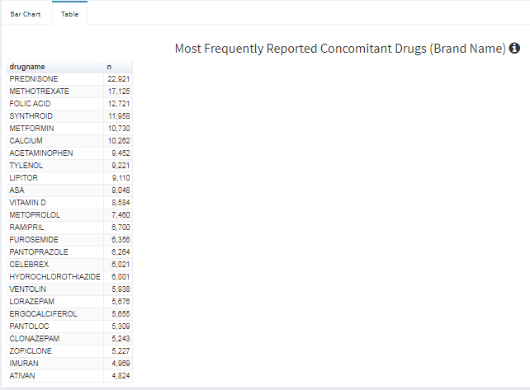

#### Reports per Indication (all reported drugs)

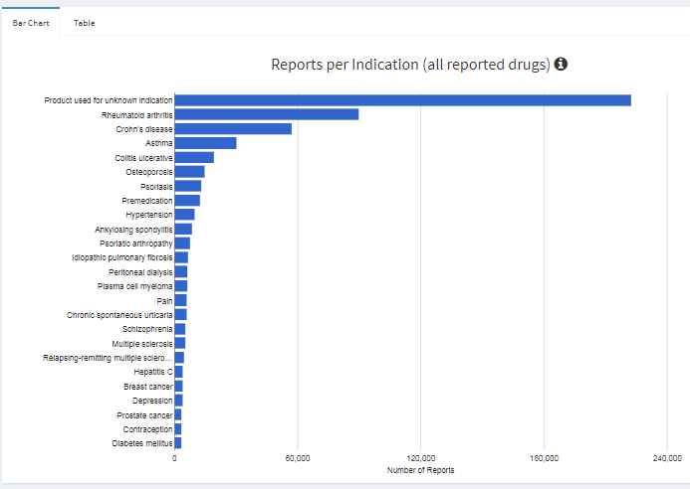

Tool Tip

This bar graph displays the reports per indication (all reported drugs). An indication refers to the particular condition for which a health product was taken. Indications are labeled on the Y –axis and the number of reports on the X-axis. This plot includes the indications, when provided, for all drugs present in the matching reports. The search query filters unique reports, which may have one or more drugs associated with them This dashboard displays the results in a bar graph that allows you to view the top 25 Indications for which the health product was taken, from most to least and, if you hover over the dashboard (hover over every bar) you can see the actual number of reports for each indication. You can also view the total number of reports (n) in a tabular format by simply clicking on the ‘Table’ tab next to the ‘Bar chart’ tab. See snapshot below.

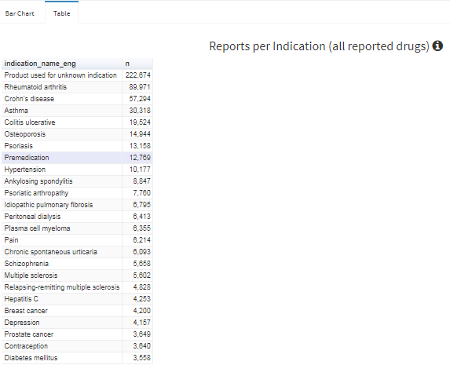

#### Number of Drugs per Report

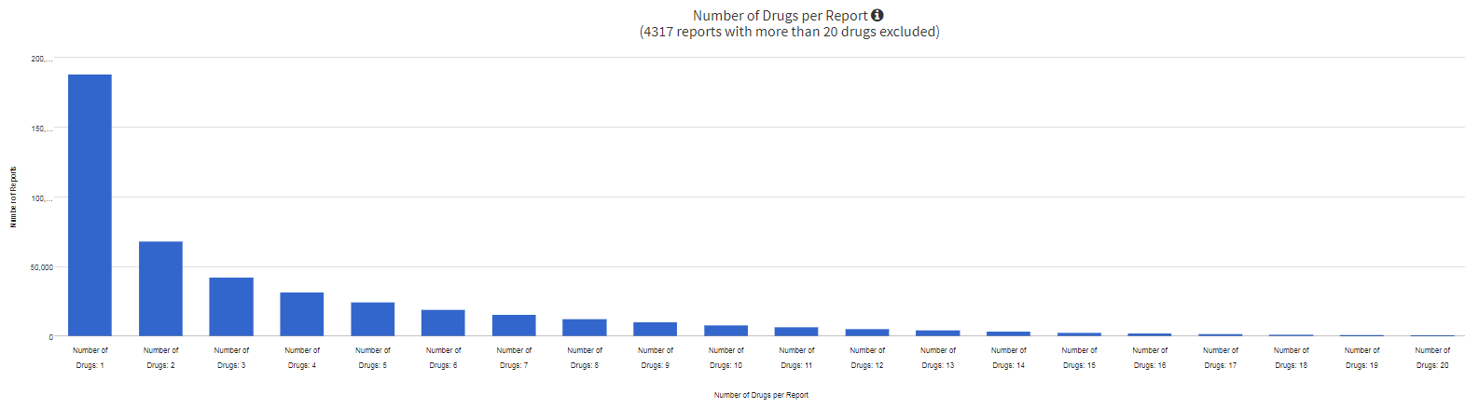

This bar graph displays the number of drugs per report. This plot indicates the number of drugs (including suspect, concomitant, past treatment) included in each report. The search query filters unique reports, which may have one or more drugs associated with them. The Y-axis represents the number of reports and X-axis represents the number of drugs present in a report corresponding to the number of reports on y -axis. The bar graph plots the number of drugs in a report from 1 to 20 (left to right). And you can view the approximate number of reports that contains drugs from 1 to 20 just by looking at the bar graph, but if you hover over the dashboard (hover over every bar) you can see the actual number of drugs corresponding to the actual number of reports (see snapshot below). Please note that any report with more than 20 drugs is excluded in this dashboard.

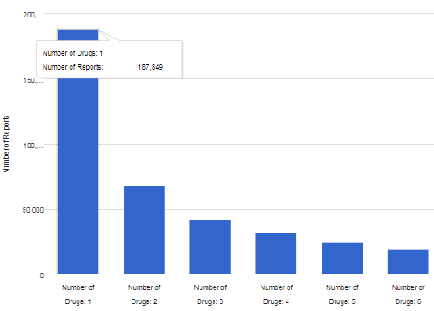

### 7.4.4 Reactions Tab

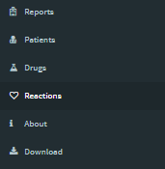

The Reactions tab is the fourth tab from the top on the side panel. The dashboards presented in this tab display graphs related to adverse reactions –both PT (preferred term) and HLT (High level term) for a default selection of All drugs and All reactions from 2000-01-01 to 2017-12-31. There is also a dashboard within this tab that displays the Report outcome along with the number of reports associated with that outcome. This tab contains three dashboards as follows:

#### Most Frequent Adverse Events (Preferred Terms)

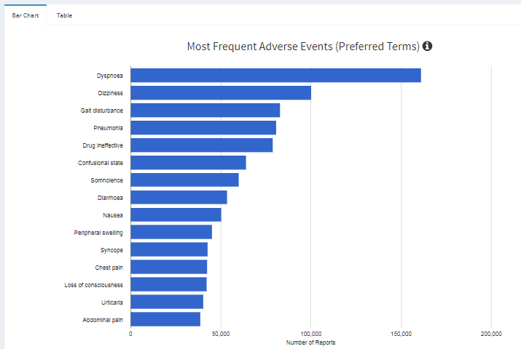

Tool Tip

This bar graph displays the most frequent adverse reaction (Preferred term) on y –axis and the number of reports associated to that preferred term on x-axis. The bars in this graph present the adverse reaction (PT) that occurred after consuming a health product from most to least (top to bottom). MedDRA preferred term is a distinct descriptor (single medical concept) for a symptom, sign, disease, diagnosis, therapeutic indication, investigation, surgical or medical problems, and medical, social, or family history characteristics. This dashboard displays the results in a bar graph that allows you to view the top 15 adverse reactions (preferred terms) that occurred with the use of a health product from most to least and, if you hover over the dashboard (hover over every bar) you can see the actual number of reports for each adverse reaction. You can also view the total number of reports (n) in a tabular format by simply clicking on the ‘Table’ tab next to the ‘Bar chart’ tab. See snapshot below.

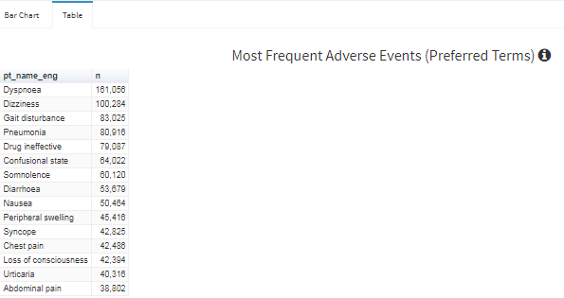

#### Most Frequent Adverse Events (High-Level Terms)

Tool Tip

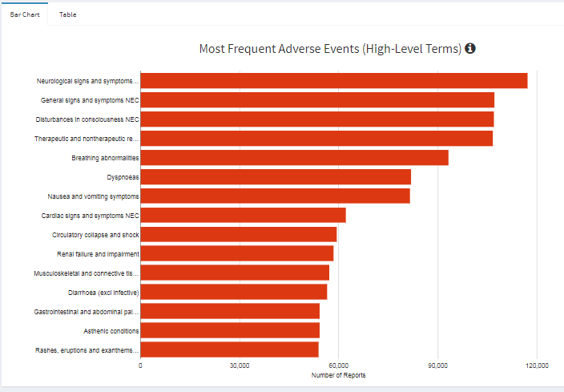

This bar graph displays the most frequent adverse reaction (High level term) on y –axis and the number of reports associated to that HLT on x-axis. The bars in this graph present the adverse reaction (HLT) that occurred after consuming a health product from most to least (top to bottom). This dashboard displays the results in a bar graph that allows you to view the top 15 adverse reactions (high level terms) that occurred with the use of a health product from most to least and, if you hover over the dashboard (hover over every bar) you can see the actual number of reports for each adverse reaction (HLT). You can also view the total number of reports (n) in a tabular format by simply clicking on the ‘Table’ tab next to the ‘Bar chart’ tab. See snapshot below.

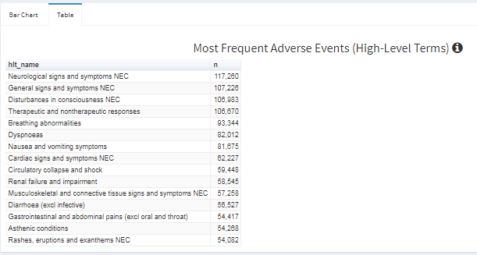

#### Report Outcome

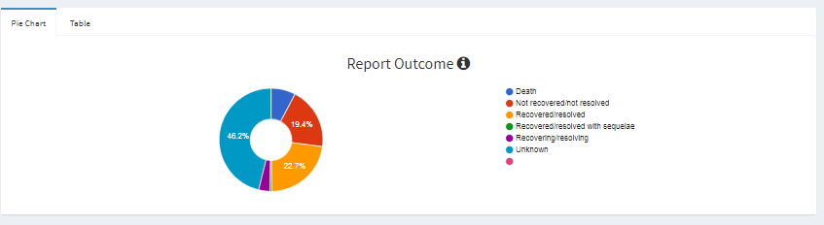

Tool Tip

This pie chart dashboard displays the outcome of adverse events reports. The report outcome represents the outcome of the reported case as described by the reporter at the time of reporting and does not infer a causal relationship. The report outcome is not based on a scientific evaluation by Health Canada. You can visualize the outcome of your search criteria (drug and reaction) in percentages. Outcomes are categorized as Death, Not recovered, Recovered, and Recovered with Sequelae, Recovering, and Unknown. Unknown includes the reports for which no outcome information has been provided. This dashboard displays the results in percentages but, if you hover over the dashboard (hover over every slice) you can see the actual number of reports for each qualification. You can also view the total number of reports (n) in a tabular format by simply clicking on the ‘Table’ tab next to the ‘Pie chart’ tab. See snapshot below.

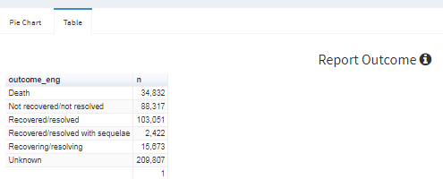

### 7.4.5 About Tab



This tab contains the following information:

* Information about the CV shiny app.
* Links to the following documents related to Canada vigilance adverse reaction
  + Caveat Document
  + Privacy statement
  + Interpretation of data
  + Glossary of fields and terms
* Date on which the data was last updated
* MedDRA version
* Names and contact details of the development team

# 8.0 Data Download



Data download tab is right below the About tab on the left side panel. Once you click on this tab you will see the following screen. Please note that data download feature will download that data which is associated to your search criteria. Also in CV shiny app, there is no limit to the number of rows so you can download the data without any limitation.

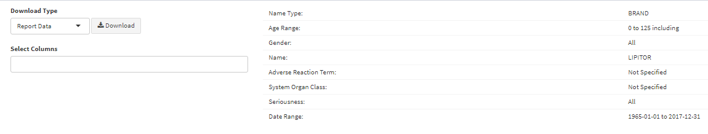

### 8.1 Download Type

The download type feature looks like following:

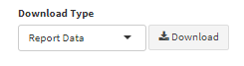

Click on the drop down arrow and it will let you select the type of data you wish to download based on your search criteria. The options of type of data are: Report Data, Drug data and Reaction data.

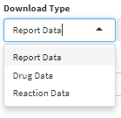

* Do not hit the Download button yet.

Once you have selected the type of data you wish to download move on to the Select Columns feature to select the columns you wish to include in your download.

### 8.2 Select Columns

The select columns feature looks like following and it is right under the Download type feature.

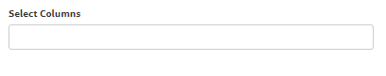

Once you have made a selection for the type of download, simply click on the empty box below the Select columns title and all the relevant columns to that type of download will appear in a drop down list. See snapshot below.

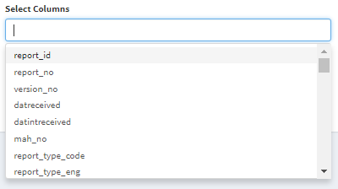

Scroll down to view additional columns

To view more columns, simply scroll down the panel to view additional columns and make selection. To select a column, simply click on the column name and it will be added to the Select Columns box. See snapshot below. Once done, click anywhere outside the box and your download criteria has now been set to download.

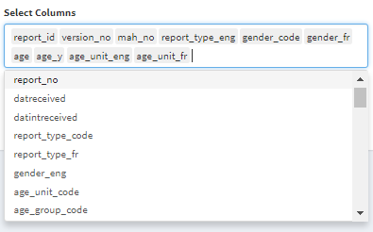

### 8.3 Download search criteria

Before you start the download, you may wish to confirm your search criteria. Based on your search, your selection will be displayed in the Download tab on the right side of the Download type feature.



Example -Search criteria is as follows:

Drug Name Type: Brand

Brand Name: Lipitor

Age Range: 20 to 75

Gender: Female

Adverse Reaction Term: Nausea

Date Range: 1965-01-01 to 2017-12-31

See the screen shot below, your search criteria automatically gets displayed in the Download Tab fields.

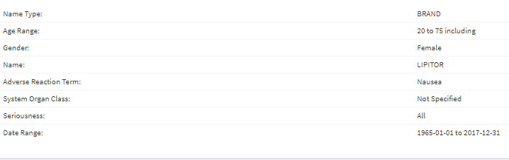

### 8.4 Download

Once you are happy with the search criteria and you have confirmed that the search criteria that you wish to download, the download type, and the columns, proceed with the Download by clicking the download button next to download type feature.

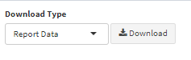

Your download will start automatically, and by default your downloaded data is saved in a .csv file format.

#### Changing the file format to Excel

By default the app downloads the data in CSV file format. Although CSV is the most compatible file format, if you still wish to convert the file format from CSV to Excel, we suggest that you do not simply save it as excel as it may lose some data, French characters or any kind of leading zeros. Follow the steps below to ensure you are not losing any data while doing the file conversion.

In Excel, do not just go to File->Open->*.csv file

This is because Excel reads any .csv as ANSI encoded, no matter if we encode it in UTF-8.

Proper way to convert .csv to .xlsx

1. Open an Excel workbook
2. In Excel, go to the Data Tab.
3. Click on "From Text" under the "Get External Data" section.
4. Navigate to the directory where the file you saved is located.
5. An Import wizard will show up. In the drop down form, make sure you select Unicode UTF-8.  
   [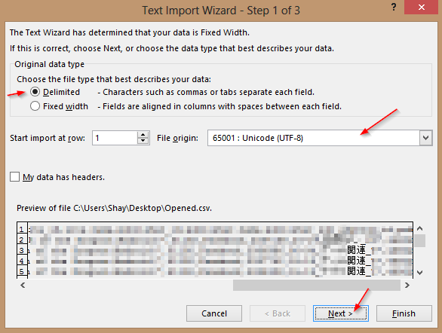](https://cloud.githubusercontent.com/assets/13026068/22253806/e9d1ec9e-e220-11e6-8938-691e02a957d6.png)
6. After clicking next, make sure to select "Comma Delimited"  
   [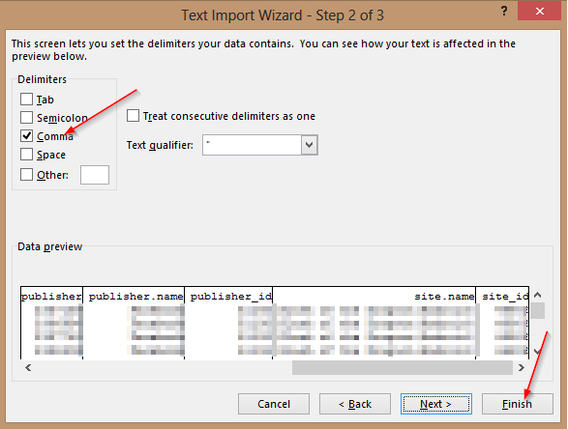](https://cloud.githubusercontent.com/assets/13026068/22253895/26c8a8cc-e221-11e6-8133-d64cda6410ef.png)
7. Click next again and click finish.

The data should have properly loaded in excel without losing any data or characters.

# 9.0 Development Team

**Unit** - Data Science Unit / Business Informatics / Resource Management and Operations Directorate / Health Products and Food Branch / Health Canada

**Daniel Buijs, MSc** [Email](mailto:daniel.buijs@canada.ca)

Manager, Data Sciences, Health Products and Food Branch

**Sophia He, BSc (in progress)** [Email](mailto:yunqingh@sfu.ca)

Jr. Data Scientist Co-op, Health Products and Food Branch

**Kevin Thai, BSc (in progress)** [Email](mailto:kthai@uwaterloo.ca)

Jr. Data Scientist Co-op, Health Products and Food Branch

**Bryce Claughton, BMath (in progress)** [Email](mailto:bclaught@uwaterloo.ca)

Jr. Data Scientist Co-op, Health Products and Food Branch

**Nanqing Zhu, MSc (in progress)** [Email](mailto:nanqing.zhu@mail.mcgill.ca)

Jr. Data Scientist, Health Products and Food Branch

**Jason Jiang, BSc (in progress)** [Email](mailto:haiyangj@sfu.ca)

Jr. Data Scientist Co-op, Health Products and Food Branch

**James Hopkins, BSc** [Email](mailto:jehopkin@sfu.ca)

Jr. Data Scientist Co-op, Health Products and Food Branch